Working against all forms of discrimination to Women and Children"

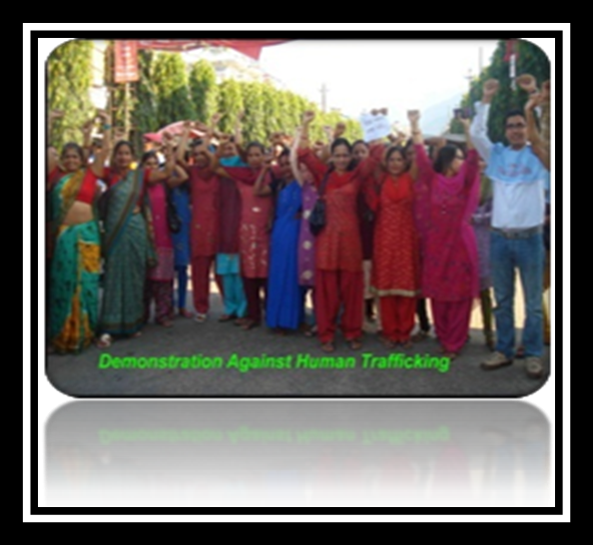
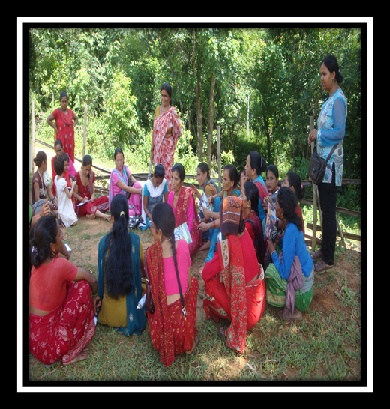

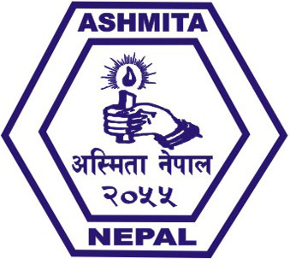
Ashmita Nepal
Hetauda-4, Makwanpur, Narayani Zone
Phone: - 057-525257, 01-4622271
Contact Office: Kathmandu, Shantinagar
Email: - ashmitanepalhtd@gmail.com
Website: - www.ashmitanp.org

Ashmita, Nepal

Ashmita Nepal was established in 1998 (2055 BS) as a non-profit making, non- political, non- governmental organization dedicated in advocating women and children’s right. The major objectives are to reduce all forms of discrimination against women, children, oppressed and marginalized community. It mobilizes women, youth, and other oppressed community for income generating activities through the utilization of Natural Resources. It is aiming to strengthen and improve the situation of women, youth and children through capacity building, skill transformation, leadership development and livelihood enhancement and ensuring human rights as well. Recently, it has been organizing activities for lobbying, advocacy and equal participation of women in decision making process and right based training and meetings for bringing improvements in the thoughts and behaviors of patriarchal society centered to right based concept. Ashmita Nepal has been implementing different activities and spreading its areas on advocacy for rights of women on natural resources, awareness campaigns regarding HIV/AIDS, and reproductive health, and capacity building to ensure the child and human rights.

Goal
Capacitate and empower women, youth, oppressed rural communities and children for exercising their rights and increasing their participation in every sector of social development ensuring their access to resources.

Mission
Reduce social stigma and discrimination and bring positive changes in the illusive concept and understanding of society towards women and children through the implementation of right based awareness capacity building, and livelihood programs.

Major Objectives
- To reduce the social fear of stigma and discrimination and bringing positive changes;
- To increase access of women in natural resources management, protection, promotion and utilization;
- To sensitize for the protection of children rights and against child labor and human trafficking;
- To ensure human rights, protection and promotion;
- To support on income generating activities and improve the livelihoods of community;
- To enhance the capacity of women, child and youths;
- To organize skill-based trainings for income generation;
- To organize training, coordination meetings, research and lobbying for reproductive health.

Thematic Areas
- Advocacy and capacity enhancement of Women's rights to Natural Resources;
- Women empowerment: Support on income generating and livelihoods opportunity.
- Climate change: Awareness, campaigns activities to women, oppressed communities and youth.
- Child rights and Human trafficking;
- Health: Reproductive and HIV/AIDS;
- Literacy program

Major Intervention
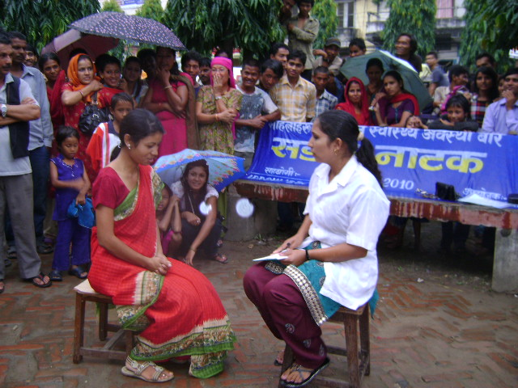
Child rights and human trafficking
- Human trafficking program
As a major intervention area, Ashmita has oriented in schools and colleges to raise awareness with people from rural areas on this issue on the anti-trafficking. Data collection about girls/women trafficking from all VDCs of Makwanpur District, as well as information was collected on women/girl's situations in VDCs through interaction with women volunteers, health workers and maternity workers.

2. Anti discrimination program
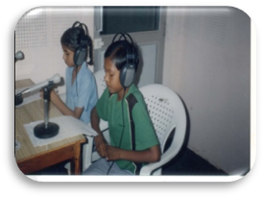
Ashmita Nepal is dedicated to the support and empowerment of women and children’s situation. Due to those interactions rallies, street dramas were carried out to raise awareness against all forms of discrimination against women and children.

3. Children rights promotion
For the promotion and ensure the child right different activities such as radio programs were carried out as well as activities like as training, interaction and discussion related to child right are still on-going among guardians, teachers, and with the women groups and children clubs. Local children are trained and empowered to run a radio program and speak about child rights.

4. Human Rights
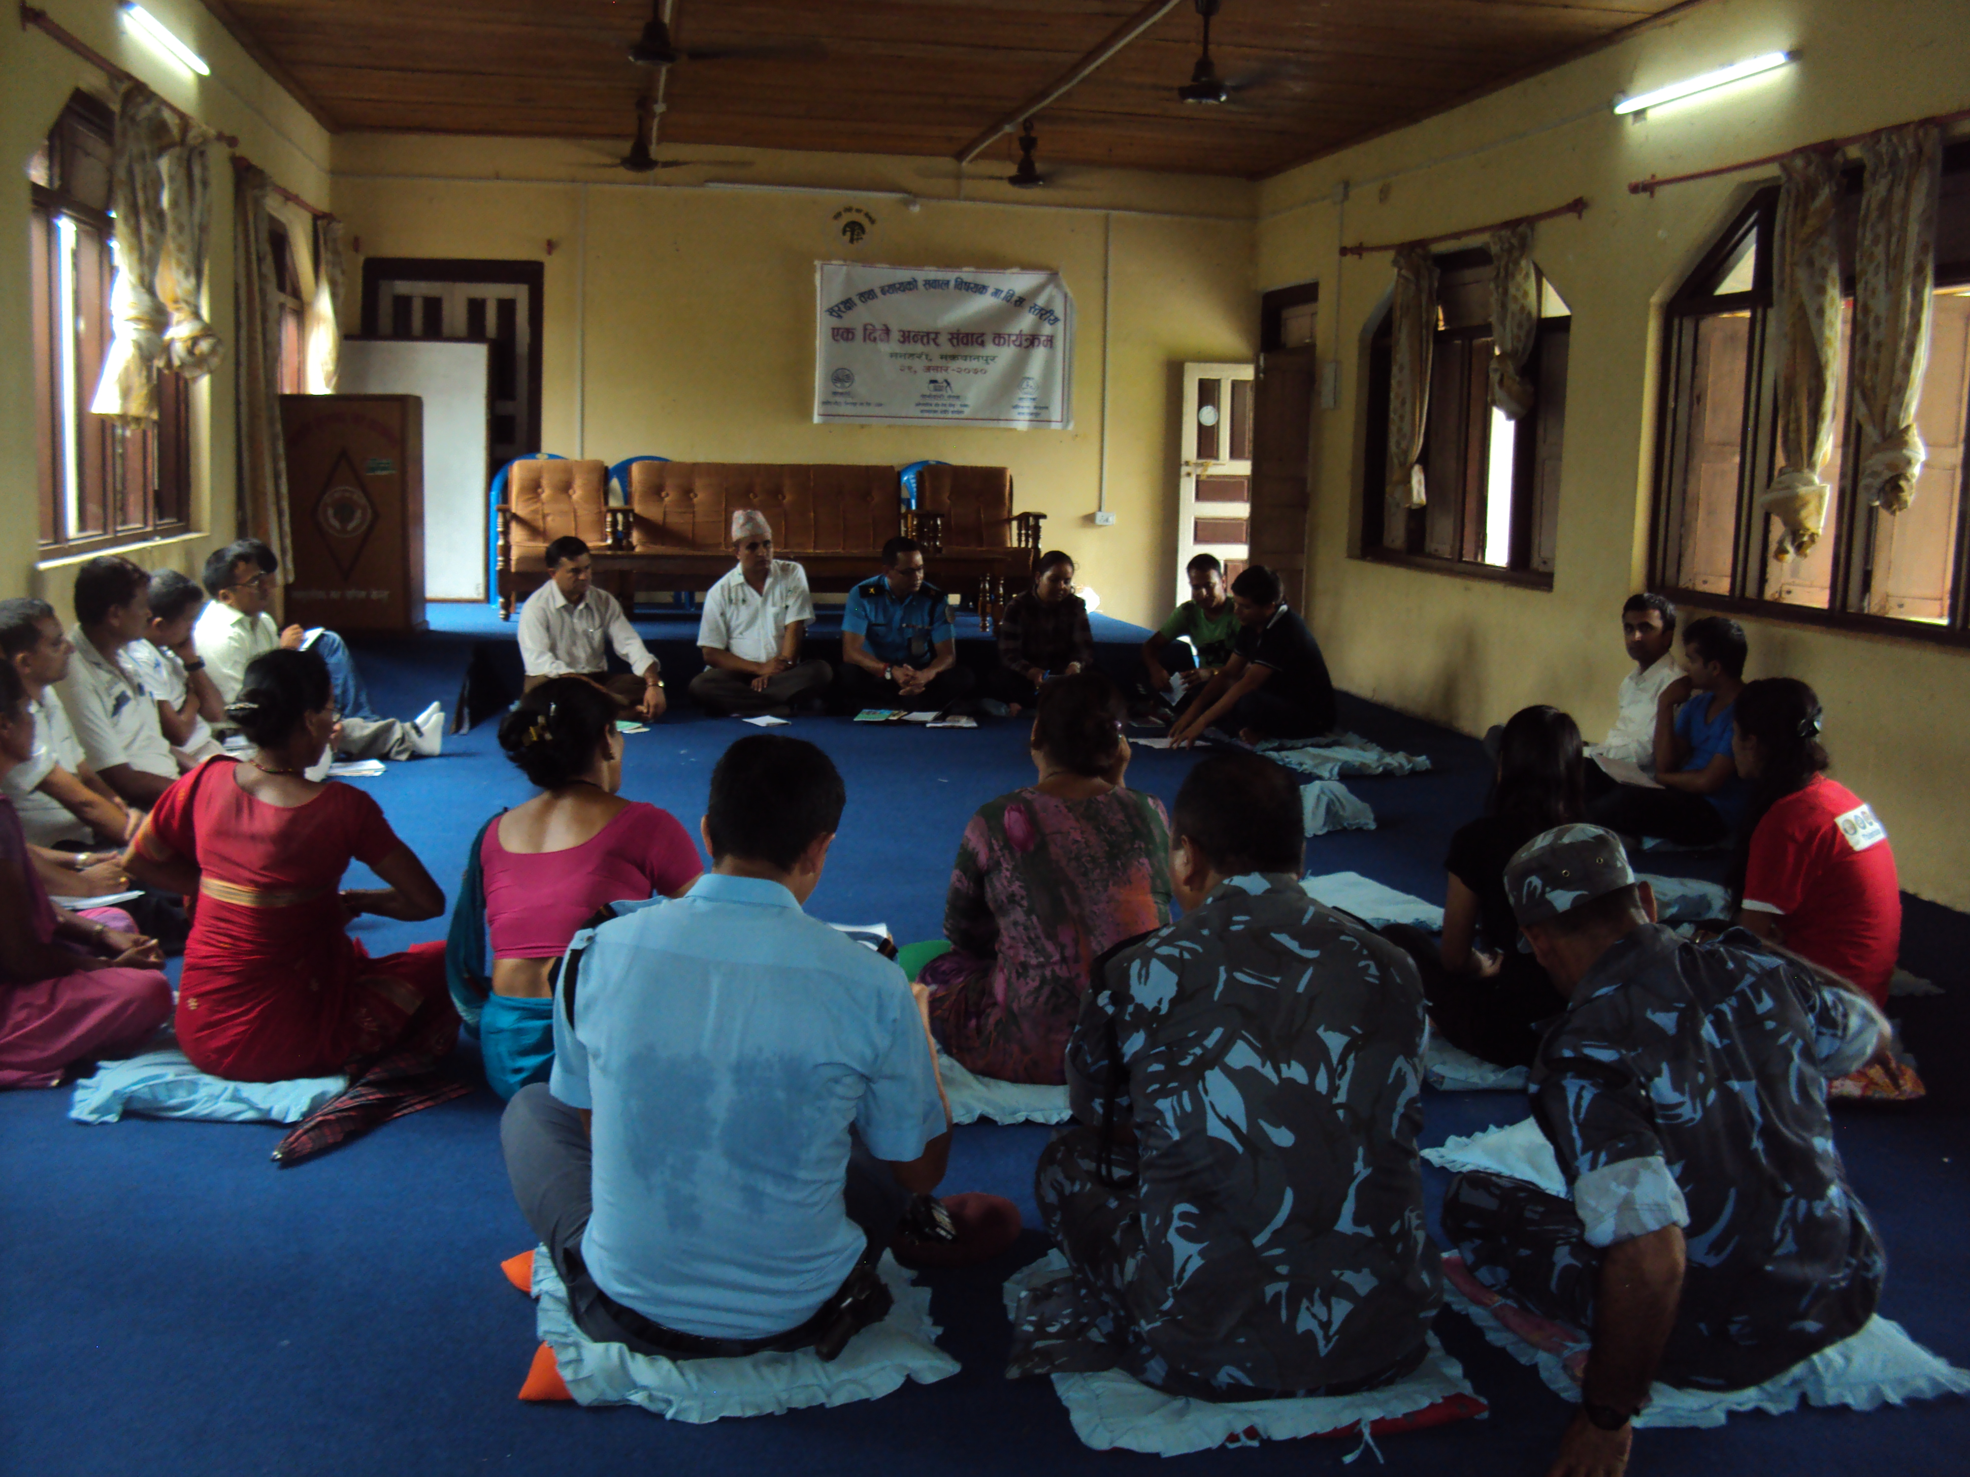
Discussion programme regarding Human Right with different key stakeholders such as; lawyers, security forces, intellectual person working on human rights were carried out and same programme on justice and security in collaboration with protection desk Nepal and USIP was also carried out.
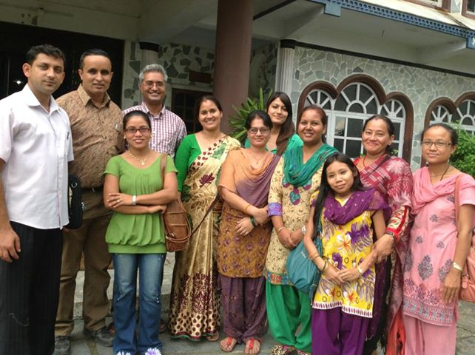

Advocacy and capacity enhancement of Women rights to Natural Resources
1. Women’s right over natural resources
Training on right based approach and orientation has been conducted to aware local users especially women about their rights and access to Natural resources as well as dialogues with different stakeholders and policy makers were held to secure women’s right on natural resources.
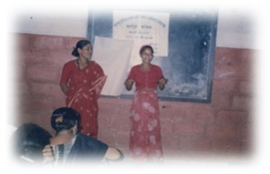

Indigenous Rights in
Community Forestry

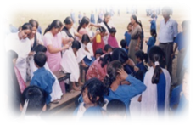
- Income generation program
Vocational training such as sewing and cutting, fabric painting, computer training and hair-dresser activities were conducted in some VDCs and Hetauda Municipality for destitute and marginalized women and youth.
Ashmita Nepal has been taking initiation in establishment of forest based enterprises with support of Growing Forest Partnership Program (Jointly Funded by World Bank, FAO, IUCN and IIED).
Hair Dressing Training for women

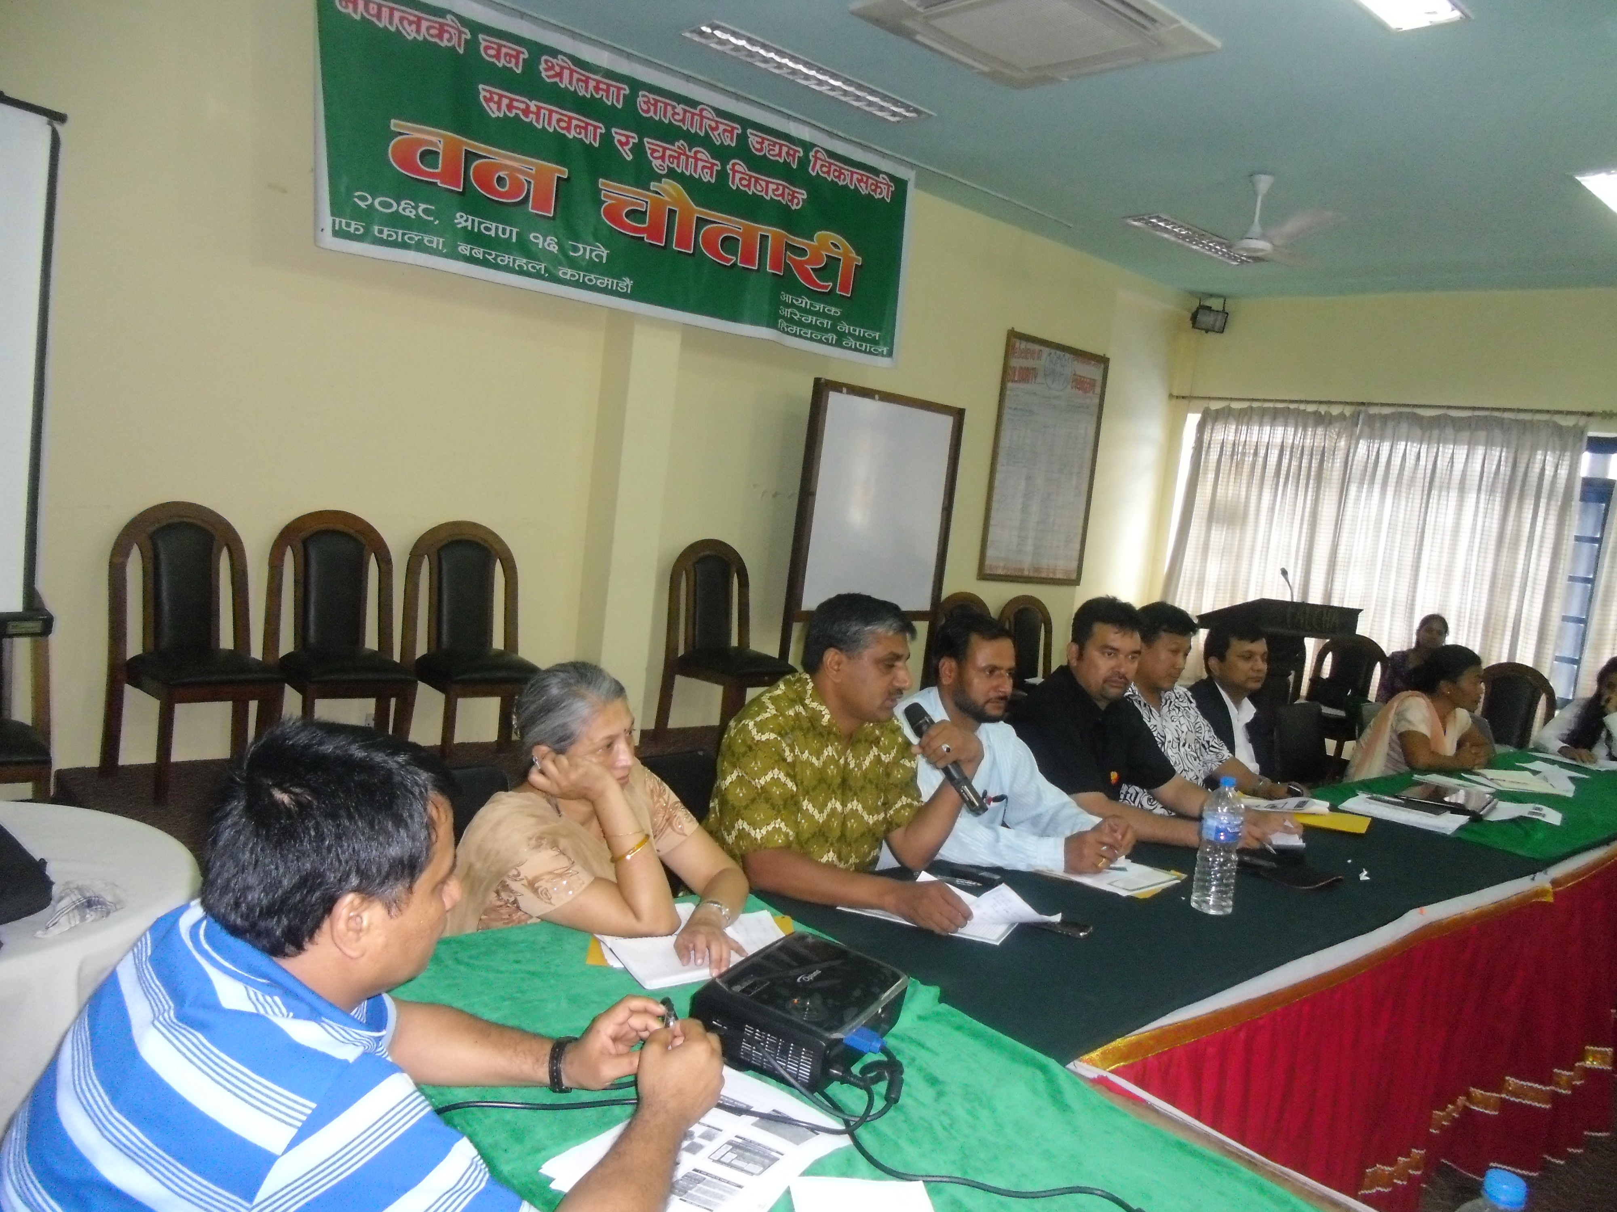
- Ban Chautari:
The organization deals with various issues to bring good governance in the forestry sector of Nepal. For this it organized dialogue among local women and media interaction and conducted two national level dialogues. It also produced video documentary which included the success stories of the women involving in enterprises. With the help of different documentary show, pamphlets and other necessary documents it tries to promote forest based enterprises and develop green job.

Reproductive Health and HIV/AIDS
Advocacy campaign was run among the rural women, media person and policy makers of VDC and made them aware about the safe maternity and reproductive health rights. Different awareness rising activities such as orientation, interaction, street drama and rally were carried out in schools, colleges and women groups aiming to aware people about HIV/AIDS. Additionally the organization run some programs like rehab centers, related to HIV/AIDS and reproductive health.
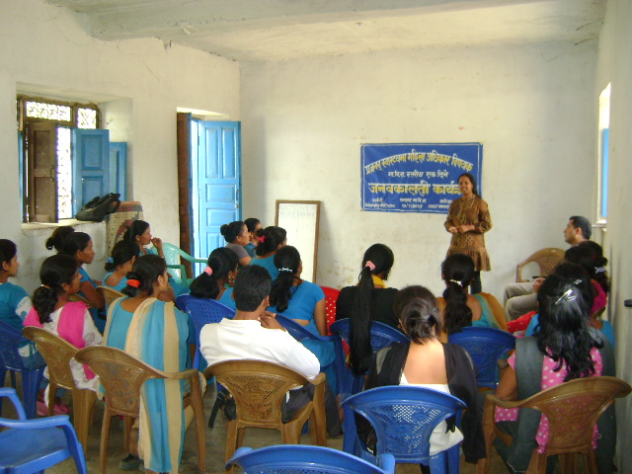
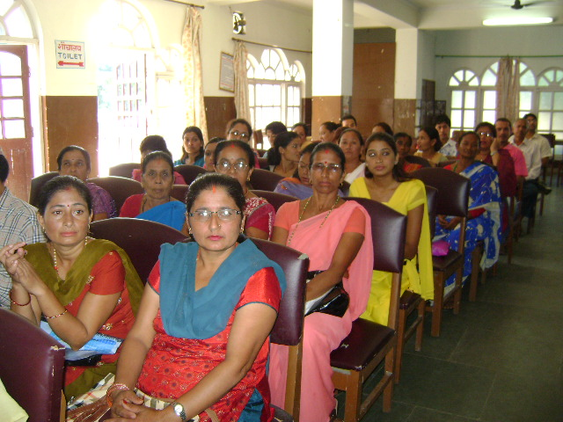

Literacy program
Ashmita Nepal has organized informal literacy classes in some VDCs as capacity building program among rural women, which has helped to bring some changes on rural women’s life. After literacy program the participant are able to do some basic calculation and read and write, which has helped to develop their self-confidence.
Working strategies
Ashmita Nepal is a local organization, which has 100 percent female participation and leadership. The organization is working in collaboration and coordination with the local, national and international female network, federations, cooperatives, and social organizations and government line agencies. The working Strategies of the organization are:
- Advocates and conducts different programs to address the issue like violence against women;
- Organizes meetings/workshops to share experience and to find out fundamental ideas from the intellectual circle;
- Works in collaboration and coordination with different partner organization;
- Helps to highlight and advertise the remarkable works done by women and children through different local media;
- Organizes exposure visits to share the experience gained by different groups of community;
- For Rural women who are engaged on farming and totally dependent on natural resources like land and water the organization initiates and encourages on the establishment of cooperatives through which they can develop saving groups and can start livelihood program by establishing micro enterprises.

Economic Source of Organization
The main economic source of organization is the registration fee and membership renewal fee. Beside an amount collected from membership fee, overhead of the program which has been conducted by the organization and the donation of different donor organizations are additional sources. Knowledge and labor paid by the volunteer plays the key role on the management and maintenance of economic resources of organization which can’t be ignored. Along with all these sources an amount collected from different programs which the organization organizes occasionally like in festival etc are supplementary.

Executive Body
Executive Body is comprised through 9-11 members and membership can be increased on inclusive way. Within board members 5 will be secretariat members and the programs run under control and coordination of secretariat members.

Name list of Board members
Bharati Pathak | President
Nirmala Neupane | Vice-President
Aarati Pathak | Secretary
Ambika BK | Joint-Secretary
Shanti Bidari | Treasurer
Pasmi Lama | Member
Godesori Thapa | Member
Pramila Kandel | Member
Sunita Lama | Member

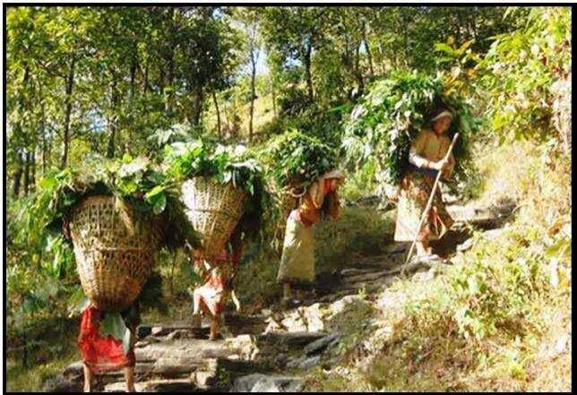
For Detail Information Please Contact us:
Ashmita Nepal
Hetauda-4, Makwanpur
Phone No: 057- 525257,01-4622271
E-mail: ashmitanepalhtd@gmail.com

Donors, collaborators with whom Ashmita Nepal is working with
UNICEF, CRIPA Nepal, Plan Nepal, DDC, Municipality, USIP, INSEC, UNDP/CHRM,HIV/AIDS Cordination Committee, MSFP/IDS

